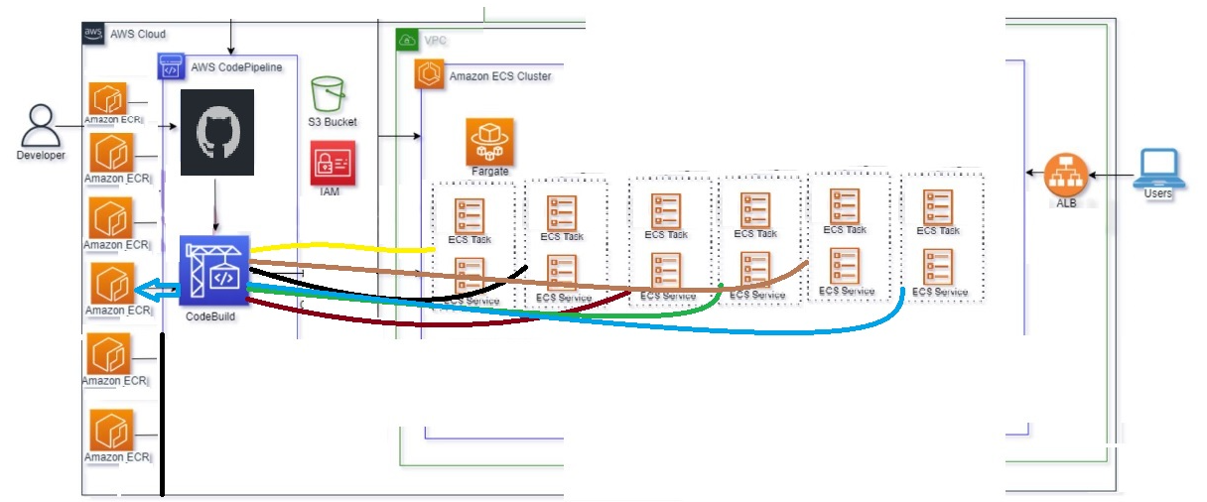

Basic understanding of the assignment

In this assignment i have created 6 ECS micro services along with VPC , SUBNET, IG , ROUTES, ROUTE TABLE, SECURITY GROUP,LB,TARGET GROUP, LISTNER GROUP,CICD PIPELINE , CODE BUILD, BUILDSPEC,GIT IAM USER POLICIES,S3 BUCKET, DOCKERFILE , INDEX.HTML,ECR.

creating docker image from docker file present in GIT , using code pipeline and code build which will

pushed the image to ECR and further that image is pushed in ecs, having single cluster and 6 microservices

each services attached to a single load balancer